So you want to stabilize some footage from your Runcam 5 Orange or iFlight GOCam PM GR?

So I know I said a separate video will be made for the rc5 orange, but working on the release stuff took more time than expected, I might make a video if I have the time, but here’s a written version in the meantime.
-Elvin

Main website: http://gyroflow.xyz/
0.3.x tutorial: https://youtu.be/f4YD5pGmnxM
Discord: https://discord.gg/2He3XTjtpt

General
The gyros in both the runcam 5 Orange and gocam PM GR can be sensitive to strong vibrations. You should therefore not hardmount the camera onto a drone, but instead use either a TPU mount or similar. The runcam 5 seems to tolerate vibrations decently well, so standard TPU or foam mounts should suffice. From limited testing, the gocam may be more sensitive to motor noise, so see if you can find or 3D print something for better vibration isolation.

Runcam 5 Orange
Surprise! All along the Runcam 5 Orange had an IMU hidden inside. This was of course previously used for the EIS, but with the newest versions of the firmware, the gyro and accelerometer data can be logged to a CSV file along with the video for post stabilization with Gyroflow.

Decent settings (bold=important for gyroflow)
- Video quality: High (duh)
- Resolution: Either 4K@30FPS(XV) or 1440p@60fps.
  - The XV resolution is actually the full 4:3 sensor stretched to a 16:9 image (supported by Gyroflow).
  - The 1440p option is natively 4:3, so if you want 60fps use this one.
  - You can also use one of the 16:9 resolutions, but this significantly reduces the available FOV for stabilization.
- Volume: You decide
- Shutter: Try to get a 90 to 180 degree shutter. So from 1/60 to 1/120 for 30fps and about 1/120 to 1/240 for 60 fps footage. (ND filter may be needed)
- ISO: As low as possible. There seems to be some auto gain regardless of settings.
- Color style: Normal (Flat squeezes the range and doesn’t actually provide mode dynamic range)
- Distortion correction: Disabled
- Electronic Image Stabilization: Disabled
General settings (there were just what I found worked decently well, so do some testing yourself)
- Saturation: Medium
- Exposure compensation: 0
- Contrast: Low
- Sharpness: Low
- Metering: Average
- White balance: Sunny (change depending on scenario, _don’t_ use auto)
- Low light enhancement: you decide.

File processing
The latest firmware I tested for the Runcam 5 had an issue with occasionally generating a duplicate frame, which leads to jitter in the stabilized output. This could be fixed by the time you read this, but otherwise there’s a way to solve it. FFmpeg has a command which can detect and remove duplicate frames. I will assume you already have FFmpeg available in the command line.
Duplicate frame detection:
Run: ffmpeg -i INPUTVIDEOFILE.mp4 -vf mpdecimate=hi=64:lo=32:frac=0.1 -loglevel debug -f null -
After feeling like Neo from the matrix for a few seconds, you see this:
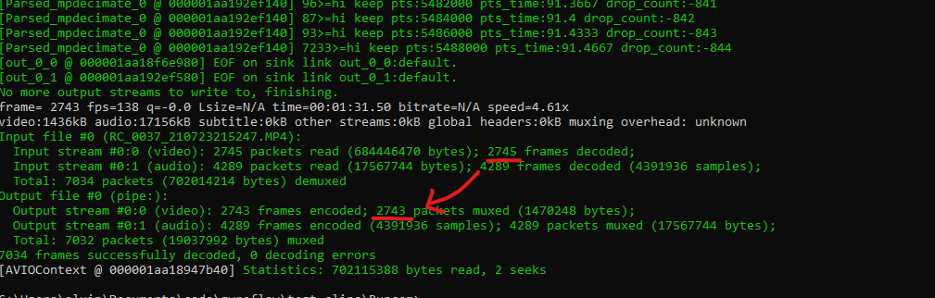
Typically there’s a duplicate frame every 30 seconds. If the input and output frames are the same, then it isn’t an issue. If they are different, we need to get rid of the duplicate frames using the following command:

ffmpeg -i RC_0001_210724181232.MP4 -vf mpdecimate=hi=64:lo=32:frac=0.1,setpts=N/FRAME_RATE/TB -c:v libx264 -crf 18 RC_0001_filtered.mp4
(replace with your filenames)
Lower value for -crf means less compression

If using an nvidia GPU (faster processing):
ffmpeg -i RC_0001_210724181232.MP4 -vf mpdecimate=hi=64:lo=32:frac=0.1,setpts=N/FRAME_RATE/TB -c:v h264_nvenc -b:v 50M RC_0001_filtered.MP4
The 50M means encoding at 50 Mbps, change if needed
replacing h264_nvenc with h264_amf may work for amd systems
Note: Keeping the pattern: RC_0001_210724181232.MP4 -> RC_0001_filtered.MP4 allows for the auto csv log matching to still work.

In Gyroflow
- If using 4K XV, use the preset: RunCam/Runcam_5_Orange_4K_30FPS_XV_16by9_stretched.json
- If using 1440p 60fps use: RunCam/Runcam_5_Orange_1440p_4by3.json
- Low pass filter cutoff at about 60 Hz should be fine
- See video guide https://youtu.be/f4YD5pGmnxM

GOCam PM GR
Depending on your setup, you might need to softmount this cam, since the the gyro can be sensitive to motor noise vibrations.

Settings
First of all, download the latest firmware.

I haven’t messed that much with the settings on this, but the main thing is, but for the current firmware, the only 4:3 resolution is 1440p 60fps. If you want the full sensor use that. Otherwise use the 4K resolution (works fine if you end up cropping to a cinematic aspect ratio)

In Gyroflow
- Use either the RunCam/Runcam_Iflight_Gocam_1440p_4by3.json preset or the RunCam/Runcam_Iflight_Gocam_PMGR_4K_16by9.json preset depending on setting
- A 50 Hz low pass filter is a good starting point.
- See tutorial

